# Resistor

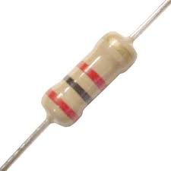

Resistor is a passive component used to control current in a circuit. Its resistance is given by the ratio of voltage applied across its terminals to the current passing through it. Thus a particular value of resistor, for fixed voltage, limits the current through it. They are omnipresent in electronic circuits.

The different value of resistances are used to limit the currents or get the desired voltage drop according to the current-voltage rating of the device to be connected in the circuit. For example, if an [LED](http://engineersgarage.com/content/led) of rating 2.3V and 6mA is to be connected with a supply of 5V, a voltage drop of 2.7V (5V-2.3V) and limiting current of 6mA is required. This can be achieved by providing a resistor of 450http://www.engineersgarage.com/sites/default/files/Ohm%20grey%203_0.jpg connected in series with the LED.

Resistors can be either fixed or variable. The low power resistors are comparatively smaller in size than high power resistors. The resistance of a resistor can be estimated by their colour codes or can be measured by a multimeter. There are some non linear resistors also whose resistance changes with temperature or light. Negative temperature coefficient (NTC), positive temperature coefficient (PTC) and light dependent resistor ([LDR](http://engineersgarage.com/content/ldr)) are some such resistors. These special resistors are commonly used as sensors.

**Resistors:**

Resistors are the most commonly used of all electronic components, to the point where they are almost taken for granted. There are many different resistor types available with their principal job being to "resist" the flow of current through an electrical circuit, or to act as voltage droppers or voltage dividers. They are "Passive Devices", that is they contain no source of power or amplification but only attenuate or reduce the voltage signal passing through them. When used in DC circuits the voltage drop produced is measured across their terminals as the circuit current flows through them while in AC circuits the voltage and current are both *in-phase* producing **0o** phase shift.

Resistors produce a voltage drop across themselves when an electrical current flows through them because they obey Ohm's Law, and different values of resistance produces different values of current or voltage. This can be very useful in Electronic circuits by controlling or reducing either the current flow or voltage produced across them. There are many different Resistor Types and they are produced in a variety of forms because their particular characteristics and accuracy suit certain areas of application, such as High Stability, High Voltage, High Current etc, or are used as general purpose resistors where their characteristics are less of a problem. Some of the common characteristics associated with the humble resistor are; Temperature Coefficient, Voltage Coefficient, Noise, Frequency Response, Power as well as Temperature Rating, Physical Size and Reliability.

In all Electrical and Electronic circuit diagrams and schematics, the most commonly used resistor symbol is that of a "zig-zag" type line with the value of its resistance given in Ohms, Ω.

Resistor Symbol:

**Resistor Symbol**

The symbol used in schematic and electrical drawings for a Resistor can either be a "zig-zag" type line or a rectangular box.

All modern resistors can be classified into four broad groups;

1. Carbon Composition Resistor - Made of carbon dust or graphite paste, low wattage values

2. Film or Cermet Resistor - Made from conductive metal oxide paste, very low wattage values

3. Wire-Wound Resistors. - Metallic bodies for heat sink mounting, very high wattage ratings

4. Semiconductor Resistors - High frequency/precision surface mount thin film technology

There are a large variety of fixed and variable resistor types with different construction styles available for each group, with each one having its own particular Characteristics, Advantages and Disadvantages. To include all types would make this section very large so I shall limit it to the most commonly used, and readily available general purpose resistor types.

Composition Resistors:

Carbon Resistors are the most common type of Composition Resistors as they are a cheap general purpose resistor. Their resistive element is manufactured from a mixture of finely ground carbon dust or graphite (similar to pencil lead) and a non-conducting ceramic (clay) powder to bind it all together. The ratio of carbon to ceramic determines the overall resistive value of the mixture and the higher this ratio is the lower the resistance. The mixture is then moulded into a cylindrical shape and metal wires or leads are attached to each end to provide the electrical connection before being coated with an outer insulating material and colour coded markings.

Carbon Resistors:

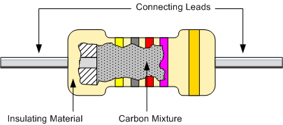

Carbon Composite Resistors are low to medium power resistors with low inductance which makes them ideal for high frequency applications but they can also suffer from noise and stability when hot. Carbon composite resistors are prefixed with a "CR" notation (e.g. CR10kΩ) and are available in E6 (±20% tolerance (accuracy)), E12 (±10% tolerance) and E24 (±5% & ±2% tolerance) packages with power ratings from 0.125 or 1/4 Watt up to 2 Watts.

Film Resistors:

The generic term "Film Resistor" consist of *Metal Film*, *Carbon Film* and *Metal Oxide Film* resistor types, which are generally made by depositing pure metals, such as nickel, or an oxide film, such as tin-oxide, onto an insulating ceramic rod or substrate. The resistive value of the resistor is controlled by increasing the desired thickness of the film and then by laser cutting a spiral helix groove type pattern into this film. This has the effect of increasing the conductive or resistive path, a bit like taking a long length of straight wire and forming it into a coil.

This method of manufacture allows for much closer tolerance resistors (1% or less) as compared to the simpler carbon composition types. The tolerance of a resistor is the difference between the preferred value (i.e., 100 ohms) and its actual manufactured value i.e., 103.6 ohms, and is expressed as a percentage, for example 5%, 10% etc, and in our example the actual tolerance is 3.6%. Film type resistors also achieve a much higher maximum ohmic value compared to other types and values in excess of 10MΩ (10 Million Ω´s) are available.

Film Resistor:

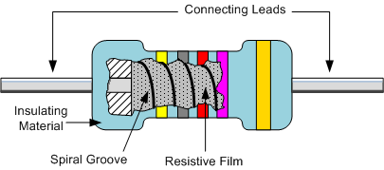

Metal Film Resistors have much better temperature stability than their carbon equivalents, lower noise and are generally better for high frequency or radio frequency applications. Metal Oxide Resistors have better high surge current capability with a much higher temperature rating than the equivalent metal film resistors.

Another type of film resistor commonly known as a Thick Film Resistor is manufactured by depositing a much thicker conductive paste of CERamic and METal, called Cermet, onto an alumina ceramic substrate. Cermet resistors have similar properties to metal film resistors and are generally used for making small surface mount chip type resistors, multi-resistor networks in one package for pcb's and high frequency resistors. They have good temperature stability, low noise, and good voltage ratings but low surge current properties.

Metal Film Resistors are prefixed with a "MFR" notation (e.g. MFR100kΩ) and a CF for Carbon Film types. Metal film resistors are available in E24 (±5% & ±2% tolerances), E96 (±1% tolerance) and E192 (±0.5%, ±0.25% & ±0.1% tolerances) packages with power ratings of 0.05 (1/20th) of a Watt up to 1/2 Watt. Generally speaking Film resistors are precision low power components.

Wire wound Resistors:

Another type of resistor, called a Wire wound Resistor, is made by winding a thin metal alloy wire (Nichrome) or similar wire onto an insulating ceramic former in the form of a spiral helix similar to the Film Resistors. These types of resistors are generally only available in very low ohmic high precision values (from 0.01 to 100kΩ) due to the gauge of the wire and number of turns possible on the former making them ideal for use in measuring circuits and Whetstone bridge type applications.

They are also able to handle much higher electrical currents than other resistors of the same ohmic value with power ratings in excess of 300 Watts. These high power resistors are moulded or pressed into an aluminum heat sink body with fins attached to increase their overall surface area to promote heat loss. These types of resistors are called "Chassis Mounted Resistors". They are designed to be physically mounted onto heat sinks or metal plates to further dissipate the generated heat increasing their current carrying capabilities even further.

Another type of wire wound resistor is the Power Wire wound Resistor. These are high temperature, high power non-inductive resistor types generally coated with a vitreos or glass epoxy enamel for use in resistance banks or DC motor/servo control and dynamic braking applications. The non-inductive resistance wire is wound around a ceramic or porcelain tube covered with mica to prevent the alloy wires from moving when hot. Wire wound resistors are available in a variety of resistance and power ratings with one main use of Power Wire wound Resistor is in the electrical heating elements of an electric fire which converts the electrical current flowing through it into heat with each element dissipating up to 1000 Watts, (1kW) of energy.

Because the wire is wound into a coil, it acts like an inductor causing them to have inductance as well as resistance and this affects the way the resistor behaves in AC circuits by producing a phase shift at high frequencies especially in the larger size resistors. The length of the actual resistance path in the resistor and the leads contributes inductance in series with the "apparent" DC resistance resulting in an overall impedance path Z. impedance (Z) is the combined effect of resistance (R) and inductance (X), measured in ohms and for a series AC circuit is given as, Z2 = R2 + X2.

When used in AC circuits this inductance value changes with frequency (inductive reactance, XL = 2πƒL) and therefore, the overall value of the resistor changes. Inductive reactance increases with frequency but is zero at DC (zero frequency). Then, wire wound resistors must not be designed into AC or amplifier type circuits where the frequency across the resistor changes. However, special non-inductive wire wound resistors are also available.

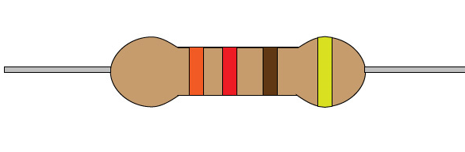

Wire wound Resistor:

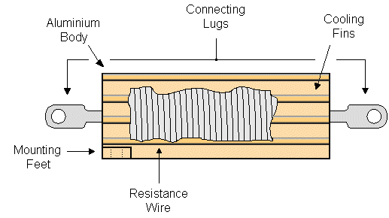

|  |
| --- |
|  |

Wire wound resistor types are prefixed with a "WH" or "W" notation (e.g. WH10Ω) and are available in the WH Aluminium Cladded package (±1%, ±2%, ±5% & ±10% tolerance) or the W Vitreous Enamelled package (±1%, ±2% & ±5% tolerance) with power ratings from 1W to 300W or more.

**Stepped or Tapped Resistors:**

A stepped or tapped resistor has two or more fixed taps that provide different resistance values. These taps allow current to flow through all or part of the resistor, which changes the amount of current flowing through the circuit. Stepped resistors can also be encased in ceramic and are nothing more than a series of fixed resistors placed end to end.